Quinoa Cakes
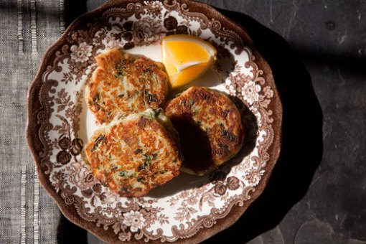
Quinoa Cakes Recipe
I love using Quinoa. I know tons of recipes for it but sometimes it’s finding that perfect little add in that gives it all you need. So, I played and played and finally found what I think are the perfect combination of flavors making this an easy, tasty, healthy dish that you will cook once and eat it a few times through your busy week. (Adapted from Barefoot Kitchen and Whole Foods Market recipes)
Ingredients
- 1 cup fresh spinach, washed patted dry and thinly chopped
- ½ tsp. garlic, inner stem removed, then minced
- 1 cup cooked red or golden quinoa
- 1 tsp. freshly minced curly parsley
- 1 1/2 tablespoon finely chopped red onion
- Zest of 1 large lemon
- ½ tsp. Sea Salt
- Dash of ground red pepper
- 1 tsp.-ish freshly ground pepper
- 1 tablespoon whole wheat Panko breadcrumbs
- 1 egg, beaten
- 3 ounces crumbled goat cheese
- Grape seed oil
Topping
- 1 1/2 tablespoon chopped fresh dill
- 1 1/2 cup plain nonfat yogurt
- 2 teaspoons lemon juice Read More http://www.mysagegourmet.com/?p=814

Directions:
- In a large bowl mix together spinach, garlic, quinoa and red onion, lemon zest, Add salt and pepper (adjust salt as needed. Add Panko and beaten egg and mix well. Make Quinoa patties about 2″ across and a 1/2 inch thick.
- In a large skillet, over medium heat, add just enough grape seed oil to cover the skillet bottom.
- Test oil by dropping a tiny piece of quinoa into the oil, It should sizzle but not pop. Adjust heat as needed.
- Place patties in skillet, careful to leave a bit of space around all sides of each patty, allows even cooking.
- Cook until browned, about 3 minutes. Flip gently to hold shape and cook on the second side 3 minutes.
- Place finished patties on a cookie sheet covered with a layer of paper towels to bloat off excess oil.
- Stir together dill, yogurt and lemon juice in small bowl, then spoon over warm quinoa cakes.

Option-YOU CAN BAKE Instead if yu make the following adjustments. Note: increases cooking time,reduces oil usage, great flavor all the same!
Preheat oven to 400°F.
ADD THESE INGREDIENTS to others above to modify for baking
- 2/3 cup grated carrots
- 2/3 cup seeded and grated yellow squash
- 1/4 cup all-purpose flour
- 1 teaspoon baking powder
DO NOT USE PANKO!!! THE FLOUR REPLACES IT AS A BINDER WHEN BAKED!
In a large bowl mix together the spinach, garlic, Quinoa and red onion, lemon zest, carrots, squash, flour, beaten egg and baking powder, omitting panko.
Form mixture into eight (4- to 5-inch) patties and arrange on an oiled baking sheet. Bake, flipping halfway through, until lightly browned and just crisp, about 25 minutes.

